Sales Analysis Innovation Ideas

* ***Product sales analysis innovation***

To innovate product sales analysis, consider these ideas:

Advanced Data Analytics: Utilize machine learning and AI to predict future sales trends, detect anomalies, and recommend sales strategies.

Real-time Data: Implement real-time data collection and analysis to make instant decisions and respond to market changes swiftly.

Customer Segmentation: Create more refined customer segments using AI, allowing for highly targeted marketing strategies.

Predictive Maintenance: Use IoT sensors to predict when products may need maintenance, reducing downtime and improving sales.

Voice and Visual Search: Integrate voice and visual search capabilities to make it easier for customers to find and purchase products.

Blockchain for Transparency: Employ blockchain for transparent supply chain tracking, which can boost consumer confidence and sales.

Personalization: Enhance personalization through AI-driven product recommendations and custom shopping experiences.

Augmented Reality (AR): Allow customers to virtually try products before buying, increasing their confidence in the purchase.

Sustainability Metrics: Integrate sustainability metrics into sales analysis to cater to the growing demand for eco-friendly products.

Competitor Analysis: Use AI to track and analyze competitor strategies in real-time, helping you adapt and stay ahead.

Remember that the choice of innovation will depend on your specific industry, market, and customer base. Certainly! To perform a basic product sales analysis in Python, you'll need data with information about products and their sales. Here's a simple example of Python code using Pandas for data manipulation and Matplotlib for visualization. This assumes you have a CSV file with product sales data:

```python

import pandas as pd

import matplotlib.pyplot as plt

# Load your data from a CSV file

data = pd.read_csv('product_sales_data.csv')

# Display the first few rows of the dataset

print(data.head())

# Calculate total sales per product

product_sales = data.groupby('Product')['Sales'].sum().reset_index()

# Plot the product sales

plt.figure(figsize=(10, 6))

plt.bar(product_sales['Product'], product_sales['Sales'])

plt.xlabel('Product')

plt.ylabel('Total Sales')

plt.title('Product Sales Analysis')

plt.xticks(rotation=90)

plt.show()

```

Make sure to replace `'product_sales_data.csv'` with the actual path to your dataset. This code loads the data, calculates the total sales per product, and then creates a bar chart to visualize the results.

* 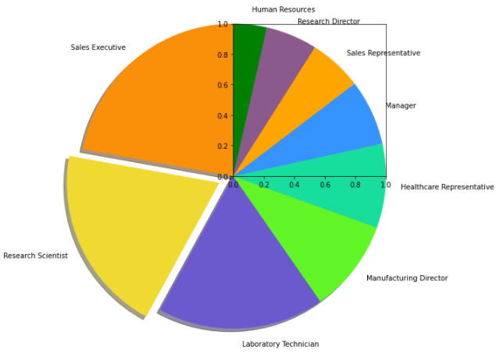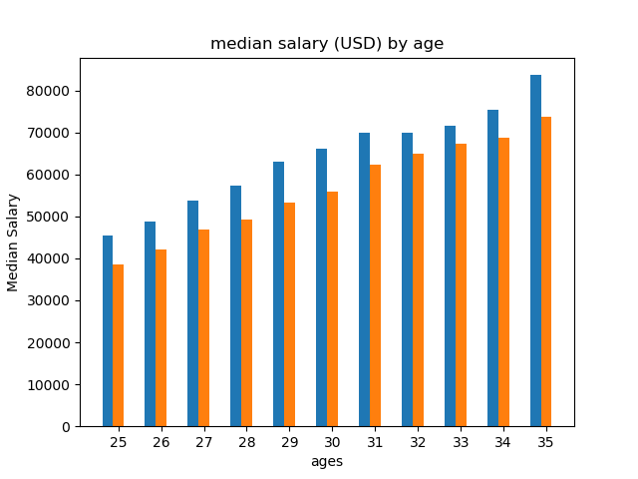You can expand this analysis by exploring different aspects of your sales data, like trends over time, best-selling products, or sales by region, depending on the available data and your specific requirements.